Users and Groups (10%)
Sunday, December 8, 2024
12:44 AM

Exam Topics

Create and manage local user and group accounts
Manage personal and system-wide environment profiles
Configure user resource limits
Configure and manage ACLs
Configure the system to use LDAP user and group accounts

Source: Linux User Account Management | USERADD, USERMOD, Examples | MPrashant

Commands

- useradd
- userdel
- usermod
- groupadd
- groupdel
- passwd
- gpasswd

Files

- /etc/passwd
- /etc/group
- /etc/shadow

- To add a user, you must be sign in as "root" user.
- If you "ls" in the /home directory, you'll get the directory related to other users. e.g. vaibhav, devops-er1, etc.

How to add a user

Run command:

1st method

useradd <username>
e.g. useradd vaibhav

2nd method

useradd -g <group_name> -s /bin/bash -c "description" -m -d /home/<user name> <user name>

-g = Specifies the group. A user can be added to any group. By default, a group is created from the name of the user.
-c = comment, You can put the comments like why a user is created.
-m = creates a directory in /home
-d = Specifies the path of home directory

How to check a user is added?

- Run "ls" command in the "/home" dir and you'll get a list of directories among which one if the directory will be named from the user you have added.

What is home directory and what is its significance?

/home – User personal data

Home directory contains personal directories for the users. The home directory contains the user data and user-specific configuration files. As a user, you’ll put your personal files, notes, programs etc in your home directory.

When you create a user on your Linux system, it’s a general practice to create a home directory for the user. Suppose your Linux system has two users, Alice and Bob. They’ll have a home directory of their own at locations /home/alice and /home/bob.

Do note that Bob won’t have access to /home/alice and vice versa. That makes sense because only the user should have access to his/her home.

- Run the "id" command. e.g. id vaibhav . You'll get the information about the user.
uid=1004(vaibhav) gid=1004(vaibhav) groups=1004(vaibhav)

What is uid, gid and groups?

To add a password to a user. Run

sudo passwd username

How to delete a user?

userdel <name of user>
userdel -r (will remove home directory)
userdel -f (force delete even if the user is logged in)

How to modify a user?

The "usermod" command in Linux is used to modify the attributes of an existing user account, allowing you to change various settings like their username, home directory, shell, group memberships, password expiration date, and even lock or unlock their account, essentially making adjustments to a user's login details without creating a new account.

To add user to a new group, but default group will
remain same
usermod -G <new_group_name> <user_name>

To change the default group, better to use --gid instead of -g to avoid the confusion between -g and -G
usermod -g <group_name> <user_name>

QA is a group already created.

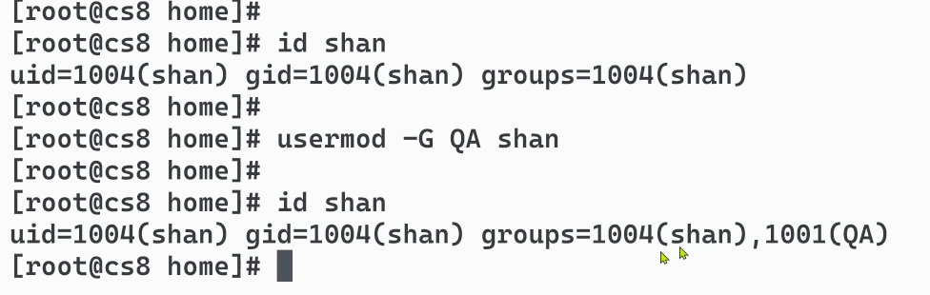

How to get more information about a group

Run command:

less /etc/group

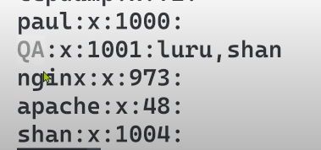

How to get more information about a group

less /etc/passwd

If a user is added to more than one group, which group will be represented by the gid?

Other usermod options:

-m -d /home/newfolder (to move the content of home folder to this new folder)

-p (we can use passwd command also)

-s shell type

-L -U (Lock/Unlock a user) = If a user is locked, he/she can't login. if you try to login, you may get "Authentication failure" error.

-m -d /home/newfolder (to move the content of home folder to this new folder). Can't we directly rename the home directory? What is the significance of -m -d then?

Renaming a Home Directory Directly:

Yes, you can directly rename the home directory, but the Linux system does not automatically update references to the user's home directory when you do this. For example:
- Files in /etc/passwd will still point to the old directory.
- The system may encounter errors when the user logs in or accesses their home directory.
Renaming without properly updating these references is not recommended, especially in multi-user environments.

Using -m and -d with usermod:
The usermod command allows you to update a user’s attributes safely. Here’s what the options do:
- -d /home/newfolder:
  - This updates the user's home directory path in /etc/passwd.
  - Without this option, the system would still think the user's home is the old location.
- -m (move):
  - This moves the contents of the current home directory to the new directory specified with -d.
  - If you only use -d, the system updates the reference in /etc/passwd but does not move any files.

Practical Example:
Suppose you want to move and rename the home directory for a user named john from /home/john to /home/newfolder:
- Without using -m:
bash
Copy code
sudo usermod -d /home/newfolder john
  - The user's home directory reference in /etc/passwd will now point to /home/newfolder.
  - Problem: /home/john still exists, and files are not moved.
- Using -m and -d together:
bash
Copy code
sudo usermod -m -d /home/newfolder john
  - The system will:
    - Move all contents of /home/john to /home/newfolder.
    - Update /etc/passwd to reflect the new directory.

Why Use -m and -d?
- Ensures the system and user environment stay consistent.
- Prevents issues where the user tries to log in but their files are in the wrong location.
- Automates moving files, reducing manual errors.

Example Questions for LFCS:
- Scenario-based Question:
You need to move a user’s home directory to /data/user1 and ensure all existing files are moved. How would you achieve this?
Answer:
bash
Copy code
sudo usermod -m -d /data/user1 username
- True/False:
  - The -m option in usermod automatically updates /etc/passwd to reflect the new home directory location.
Answer: True.
- Fill-in-the-Blank:
  - To move a user's home directory contents and update /etc/passwd, you use the -___ and -___ options with the usermod command.
Answer: -m and -d

Setting Password for a user

Run command:

passwd <user-name> = It is used to set the password to a username.

Groups

groupadd <group - name>

less /etc/group = To check if a group is created

developers:x:1002:jane

Meaning?

groupdel <group-name> = To delete a group

To add a user to a group, run:

sudo gpasswd --add john developers
sudo gpasswd -a john developers

This will add a user "john" to the group "developers"

To check the groups, a user has been added to, run:

groups john

Output- john: john developers

The first group written after john is the primary/login group.

Finding a User’s Primary Group
The /etc/passwd contains each user and their primary group.

To remove a use from the group, you can run:

sudo gpasswd --delete john developers
This will remove john from the "Developers" group.

gpasswd expects first the user and then the group and this is vice versa for usermod. e.g.

sudo gpasswd --add john developers
usermod -g <group_name> <user_name>

To modify a group

TO change the group name from developers to programmers.
sudo groupmod -n programmers developers

If you get the error like, can't remove the primary group. Then make other group of that user as primary which you don't wish to delete.

/etc/shadow

To get information about last password changed, etc.

The general format of /etc/shadow is:
username:password:lastchg:min:max:warn:inactive:expire:reserved

example

jane:!:20068:0:99999:7::21974:

Explanation of the Fields in jane:!:20068:0:99999:7::21974:
- jane (Username):
  - The login name of the user.
- ! (Password):
  - Indicates that the password for this account is locked.
  - This prevents the user from logging in using a password.
  - Other possibilities:
    - * → Account is disabled.
    - A hash (e.g., $6$hash) → Contains the hashed password.
- 20068 (Last Password Change):
  - The number of days since January 1, 1970 (Unix Epoch) when the password was last changed.
  - For 20068, it corresponds to October 20, 2024.
- 0 (Minimum Password Age):
  - The minimum number of days the user must wait before changing the password again.
  - 0 means the user can change their password immediately.
- 99999 (Maximum Password Age):
  - The maximum number of days the password is valid before the user is forced to change it.
  - 99999 essentially means the password does not expire.
- 7 (Warning Period):
  - The number of days before the password expires when the system starts warning the user to change their password.
- : (Inactive and Expire Fields):
  - Inactive (inactive):
    - Number of days after the password expires during which the account remains usable.
    - Empty here (:) means no inactivity period is set.
- Expire (expire):
  - Number of days since Unix Epoch when the account will be disabled.
  - Empty here (:) means no expiration date is set.
  - e.g. 21974 = It has been 21974 days since Jan 1 , 1970

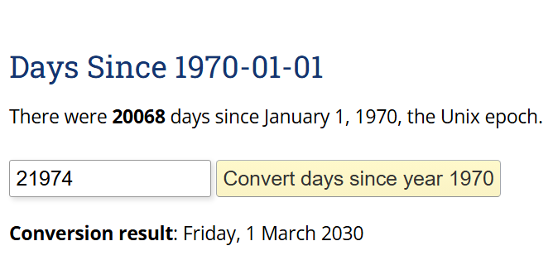

/etc/skel

When a new user or account ( both are same) is added. The /home/<user> would initially contains all the files present in the /etc/skel directory.

skel means skeleton

Typically files included in /etc/skel are .rc files

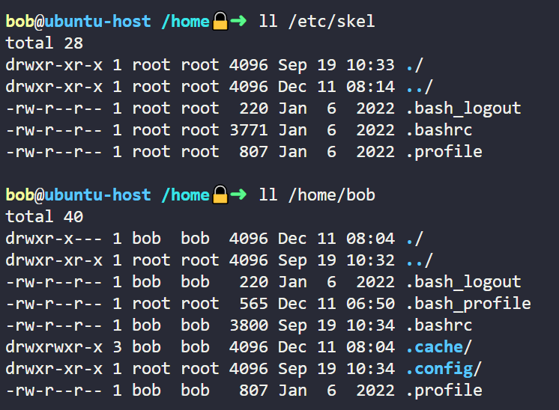

System Accounts

A system account (or system user) is a special type of user account
primarily used for managing system services, processes, and applications.
These accounts are not meant for human users to log in interactively but instead are used by the system itself for specific tasks.

They manage system services like databases, web servers, or background processes (e.g., apache, mysql, sshd)

System accounts often have their login shell set to /sbin/nologin or /bin/false to prevent interactive login.

UID Range:
- System accounts typically have user IDs (UIDs) in a reserved range:
  - RHEL/CentOS: UIDs 0–999 are usually reserved for system accounts.
  - Normal user accounts start at UID 1000 by default.
- UIDs are stored in /etc/passwd.

Examples of System Accounts:
- root: The superuser with full system access (UID=0).
- apache: Used by the Apache HTTP server.
- mysql: Used by MySQL database server.
- sshd: Used by the SSH daemon.

How to create a system account?

sudo adduser --system --no-create-home <system-account-name>

System accounts usually don't have home directories.

chage Command

The chage command changes the number of days between password
changes and the date of the last password change. This information
is used by the system to determine when a user must change their
password.

Command to set the password immediately as expired.
sudo chage --lastday 0 jane or sudo chage -d 0 jane

Sets the "last password change date" to never.
Effect: It removes the record of when the user last changed their password.
The system treats the user's password as if it has never been changed.

sudo chage --lastday -1 jane

Command to change the password every 30 days
sudo chage --maxdays 30 jane OR sudo chage -M 30 jane

Command to set the password never expires
sudo chage --maxdays -1 jane OR sudo chage -M -14 jane

To see when the password expires
sudo chage --list jane

KK Lab1 - User and Groups - RedHat
Wednesday, December 11, 2024
11:14 AM

Set the jane user account to expire on March 1, 2030.

1st Method

sudo usermod jane -e 2030-03-01

2nd Method
sudo chage -E 2030-03-01 jane

3rd method (it is not recommended to edit these files directly)
edit the /etc/shadow file.
Total no of days from 1 Jan 1970 to 1 March 2030 = 2030 21974.
Edit the jane section, so that it looks like
jane:!:20068:0:99999:7::21974:

How to Verify the Account Expiry Date:

1st method

The ‘chage’ command, short for “change age,” used to manage user password expiry and account aging information.

sudo chage -l jane

Last password change : Oct 20, 2024
Password expires : never
Password inactive : never
Account expires : Mar 01, 2030
Minimum number of days between password change : 0
Maximum number of days between password change : 99999
Number of days of warning before password expires : 7

2nd method
sudo grep jane /etc/shadow

Output of Following file before

sudo vi /etc/shadow
jane:!:20068:0:99999:7:::

Output of following file after

sudo vi /etc/shadow
jane:!:20068:0:99999:7::21974:
Total no of days from 1 Jan 1970 to 1 March 2030 = 2030 21974.

To remove an expiry date, Run:
sudo usermod jane -e ""

Create a system account called apachedev

1st Method
sudo useradd --system apachedev

Verify:

cat /etc/passwd
apachedev:x:107:65534::/home/apachedev:/usr/sbin/nologin
UID- 107 which is in the range 0-999

2nd Method
adduser --system apachedev

Change the expiry date of a user to never expire.

usermod -e "" jane

Verify:

- sudo chage -l jane

- cat /etc/shadow
jane:!:20114:0:99999:7:::y

Add a user with home dir and default shell as /bin/csh

sudo useradd -s /bin/csh -m jack

-m - It is used to create home directory.

verify:

cat /etc/passwd
jack:x:1002:1002::/home/jack:/bin/csh

sudo useradd -s /bin/csh -d /custom/path/jack -m jack
-d option is used to provide the custom home directory to the user.

useradd vs adduser

The useradd command in Linux is used to create a new user account. The command adds the necessary entries to the system files, creates the home directory for the user, and sets up the initial configuration files.

The adduser command is much interactive as compared to useradd command.

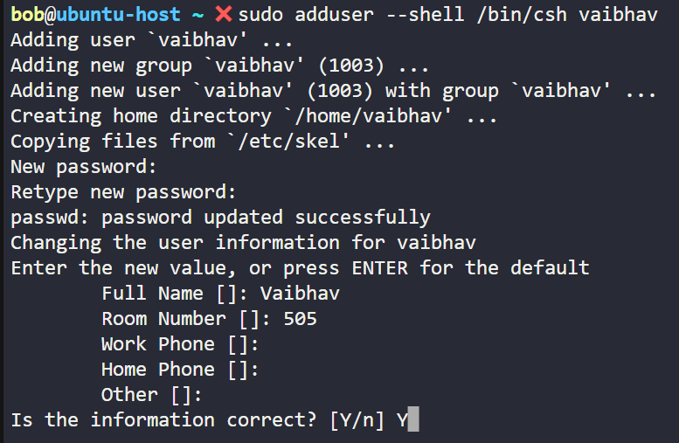

Delete the user account called jack and ensure his home directory is removed.

sudo userdel -r jack

userdel: jack mail spool (/var/mail/jack) not found

Verify:

cat /etc/passwd

Mark the password for jane as expired to force her to immediately change it the next time she logs in.

sudo chage --lastday 0 jane
-d, --lastday LAST_DAY set date of last password change to LAST_DAY

jane:x:0::::::

sudo passwd --expire jane
This command sets the password status to expired, prompting Jane to set a new password upon her next login.

Add the user jane to the group called developers.

sudo usermod -a -G developers jane

developers:x:1008:jane

-G, --groups GROUPS new list of supplementary GROUPS
-a, --append append the user to the supplemental GROUPS
mentioned by the -G option without removing
the user from other groups

If you don’t add the '-a' option, the jane will be removed from the other groups

Example

sudo usermod -G vaibhav jane

/etc/group

developers:x:1008:
vaibhav:x:1003:jane

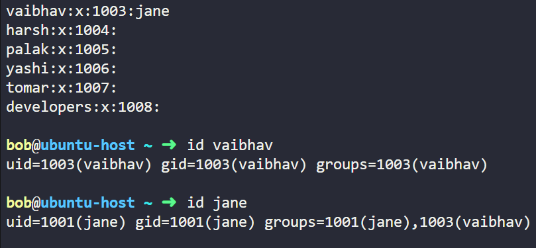

2nd method

developers:x:1004:jane

Create a group named cricket and set its GID to 9875

sudo groupadd -g 9875 cricket

Verify:

cat /etc/group

You already created a group cricket in the previous question. Now, rename this group soccer while preserving the same GID.

sudo groupmod -n soccer cricket

-n <new group> <old group>
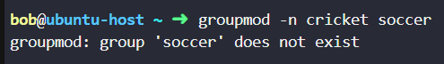

Update primary group of user sam and set it to rugby

sudo usermod -g rugby sam

useradd -b

Delete the group called appdevs.

sudo groupdel appdevs

Make sure the user jane gets a warning at least 2 days before the password expires.

sudo chage -W 2 jane

Manage System - Wide Environment Profiles
Thursday, December 12, 2024
1:44 AM

How to set Environment Variables in Linux? [HINDI]

What are Env Variables?

Allows you to store data in memory that can be easily accessed by any program or script
running from the shell.

e.g. SHELL=/bin/bash

How to see the existing Env Variables?

printenv

env
Display Current Environment Variables: By running env without any arguments, it lists all the environment variables and their current values in the session.

Set Temporary Environment Variables: You can specify environment variables that will be available only to the executed command.

env VAR1=value1 VAR2=value2 command

In this example, command runs with VAR1 and VAR2 set to value1 and value2, respectively.

Ignore the Current Environment: Using the -i or --ignore-environment option, env starts with an empty environment, ensuring that only the specified variables are set for the command.

env -i VAR1=value1 command

Here, command runs with a clean environment where only VAR1 is defined.

How to see a specific Env Variable?

printenv HOME
echo $HOME

Does each user has different env variables in linux?

Yes, each user in Linux can have their own set of environment variables. While some environment variables are common to all users, many can be customized to suit the specific needs of individual users.

There are two environment variable types in the bash shell:

Global variables

Local variables - It is limited to current shell only. Suppose a user "Paul" has created a local variable "MY_VAR", It is not necessary that it will be created in other shell/terminal open by same user "Paul".

How to create local user-defined variables that are visible within your shell process.

MY_VAR=Hello
echo $MY_VAR

MY VAR="Hello World"
echo $MY_VAR

unset MY_VAR - This will unset the variable.

export MY_VAR=Hello
This will add the "MY_VAR" to the environment variables which you can list out using "printenv" command. But this will still not be listed when you run the "printenv" command on another terminal.

So, it’s still a local variable.

Set Env variable permanent for a user.

~ = This is the symbol for home directory. e.g. /home/paul

- Edit ~/.profile (ubuntu) or Edit ~/.bash_profile (centos). e.g. vi ~/.bash_profile
- And set variables in the .bash_profile and then save it(:wq). export MYVAR=VALUE
- source ~/.profile (to apply immediately into current shell). So, if you have already edited the .bash_profile then run source command to use the environment variable on the current shell every time.

This is only applicable for the user which is currently logged in.

To make permanent changes so that you don't have to use source command or saving and environment variables so that every user can use it who logged in to the system

Save the environment variable on the .bashrc file in the last. This way, you need not to run the source command on new terminal every time.

ENV variable for all the user or Global Variable

• Edit /etc/profile/

And set variables

• export MYVAR=VALUE
• source /etc/profile/

/etc/environment file
The `/etc/environment` file in Linux is a powerful tool that enables users to control environment variables at a system-wide level (globally).

/etc/profile Bash shell defaults.

/etc/profile.d It contains other scripts like application scripts, executed after login

Global Env Variable

$GLOBALENV

System-wide (global) environment variable → Edit /etc/environment
/etc/environment → Only for static variables (no shell scripting).

User-specific environment variable (for the current user) → Edit ~/.bashrc (or ~/.profile for login shells)
~/.bashrc → Runs for every new interactive shell (e.g., opening a terminal).
~/.profile → Runs for login shells (e.g., SSH login).

Run commands after any user logs in → Add a script to /etc/profile.d/
/etc/profile.d/*.sh → Runs for all users when they log in.

A login shell is a shell session that starts when a user logs into the system, such as through SSH or a graphical login.

A non-login shell is a shell session that does not require a full user login. It typically runs when opening a new terminal in an already logged-in session.

Files Read by a Non-Login Shell:
~/.bashrc → (User-specific shell customizations)

Manage System-Wide - Labs

To set environment variables globally for all users, you can define them in /etc/environment. For user-specific environment variables, adding them to the user's ~/.bashrc file is appropriate.

Which of the following environment variables holds the value of user's home directory?
echo $HOME

Which of the following files can be used to set the globally available environment variables in a Linux-based system?

The /etc/environment file can be used to set the globally available environment variables in a Linux-based system.

Print our current user's (bob) environment

env > /home/bob/env

Add an environment variable for user bob.
The variable name should be MYVAR and its value should be TRUE

Edit .bashrc file:
vi ~/.bashrc

add the variable at the end of the file:
export MYVAR=TRUE

save the file and run:
source ~/.bashrc

Whenever we add a new user to the system, some files are copied from a template directory to the user's home directory.

Manually copy those files into the /home/bob/default_data directory.

sudo cp /etc/skel/.bash* /home/bob/default_data/

OR

cp -r /etc/skel/. /home/bob/default_data

Other method

cp -r /etc/skel /home/user

This will copy hidden files if the destination folder don't exist.

Modify the system-wide environment file and make sure that the variable GLOBALOPTION is set to this value: ON. Otherwise, after you modify that file, any user that logs in and types…

sudo vi /etc/environment

source /etc/environment

Make sure that this command gets executed for any user that logs in to the system:

Create a file with .sh extension at location /etc/profile.d/, for example:

sudo vi /etc/profile.d/welcome.sh
And save in it the line given below:

echo "Welcome to our server!"

/etc/profile.d It contains other scripts like application scripts, executed after login

Make sure that every time a new user account is added to the system, a file called README is copied to the new user's home directory.

Whenever we create a new user in Linux, the files in the /etc/skel directory get copied into the user's home. So, we can create a README in the /etc/skel directory so that it gets copied to the newly created user's home.
Execute the below command to do so:

sudo touch /etc/skel/README

Set a variable named LFCS with value Welcome to the KodeKloud LFCS Labs! for every user that logs into this system.

Edit the /etc/environment file:
sudo vi /etc/environment
Add the below line at the end of the file:
LFCS=Welcome to the KodeKloud LFCS Labs!

Add the value of $PATH variable for user bob to include $HOME/.config/bin location in the path.

vi /home/bob/.bashrc
Add the PATH variable value so that it looks like this and save it:

PATH="$HOME/.local/bin:$HOME/bin:$HOME/.config/bin:$PATH"

source ~/.bashrc

What I did, which was also accepted:

PATH=$HOME/.config/bin

Manage Template User Environment
Saturday, December 14, 2024
3:32 PM

We can add any file under /etc/skel/ directory so that when a new user is created all these files under /etc/skel/ directory get copied under /home/<username>/ directory.

Configure User Resource Limits
Saturday, December 14, 2024
3:36 PM

Files and Commands

/etc/security/limit.conf
sudi -iu <username>
ulimit

/etc/security It contains the name of terminals where root login is possible.

To set a limit on user's resource utilization, so that they can't use any amount of CPU etc.
To set this limit, we can use /etc/security/limits.conf

Syntax of limits.conf file

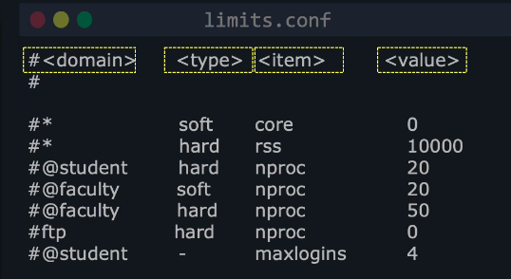

<domain> -

In this field, we need to name whom we are going to limit. The following can be values of this field

  - username
  - group name
  - * specifies all
  - userid
  - groupid

trinity hard nproc 10
@developers soft nproc 20

e.g. * soft cpu 5

<type> - It can be hard, soft and - .

  - hard Limit - A hard limit can not be overridden by a user. The user can not cross the mentioned values.

  - Soft Limit - User can cross the mentioned value till a Hard value that has already been set to for the given domain.
  - "-" - The - is the third <type>. It means , it is a soft and hard limit both. A <domain> having this means it can use up to atmost this limit specified without manually increasing the limit.
e.g. trinity - nproc 20

So, If a user is "trinity" and it has a soft limit set to 10 for processes and hard limit is 20.

trinity soft nproc 10
trinity hard nproc 20

If required, trinity can increase its process limit manually to 11, 12 etc. but less than 20.

item
This field mentions which resource we are going to limit for the mentioned domain. Here are some values for this field
  - core: limits the core file size in KB
  - data: maximum data size in KB
  - fsize: maximum file size in KB
  - stack: maximum stack size in KB
  - cpu: maximum active CPU time in minutes. It can be possible than a process is running since 3 hours but only utilizes the 2 min of cpu. The rest of time was idle or process was at sleep
  - nproc: maximum no. of processes

sudo -iu <username> logs you in as <username>, without having to know <username>'s password.

You have to be on the sudoers list for this to work

ulimit

ulimit is admin access required Linux shell command which is used to see, set, or limit the resource usage of the current user.

ulimit -u: To display maximum users process or for showing maximum user process limit for the logged-in user.

ulimit -u 5000: It will set or lower the limit to 5000. It is only used for lowering the limit only. You can change your soft limits for the current shell environment, up to the maximum set by the hard limits.

Once hard limit is set it can only be lowered never raise, but soft limit can be lowered or raised provided that the value stays lower than the hard limit.

User and Groups: Manage User Privileges
Saturday, December 14, 2024
8:19 PM

Important Files

/etc/sudoers
gpasswd

super user and root user are same.

groups

This command provides the information of a user who is currently logged in.

To add a user to group "sudo", run this command.
sudo gpasswd -a <user> sudo

To remove a user to group "sudo", run this command.
sudo gpasswd -d <user> sudo

visudo

The sudo command is configured through a file located at /etc/sudoers.

The /etc/sudoers file controls who can use sudo and what commands they are allowed to run with elevated privileges. It defines user and group permissions for executing commands as root or another user.

root ALL=(ALL:ALL) ALL The first field indicates the username that the rule will apply to (here it's root).

root ALL=(ALL:ALL) ALL The first “ALL” indicates that this rule applies to all hosts.

root ALL=(ALL:ALL) ALL This 2nd “ALL” indicates that the root user can run commands as all users.

root ALL=(ALL:ALL) ALL This 3rd “ALL” indicates that the root user can run commands as all groups.

root ALL=(ALL:ALL) ALL The last “ALL” indicates these rules apply to all commands.

Names beginning with a % indicate group names.

%developers ALL=(ALL) ALL

trinity ALL=(aaron,john) ALL - This specifies the trinity user to run all the commands as user "aaron" and "john" only. Since it is written inside the small braces "()". So, this field is optional.

trinity ALL=ALL is also same as above command.

trinity ALL=(ALL) /bin/ls OR
trinity ALL= /bin/ls

This trinity user can only run ls command. Running other command such as echo etc. will give error.

If you want a user to run sudo command without password, run following command:

trinty ALL= NOPASSWD:ALL

Explain:

trinity ALL=ALL
trinity ALL=(ALL:ALL)
trinity ALL=(ALL:ALL) ALL

trinity ALL=ALL
This entry is not correct in sudoers because it lacks the command specification.
It should be trinity ALL=(ALL) ALL to allow trinity to execute any command as any user.

trinity ALL=(ALL:ALL)
trinity can run commands as any user (ALL) and any group (ALL).
Equivalent to trinity ALL=(ALL) ALL, since :ALL (group specification) is optional.

trinity ALL=(ALL:ALL) ALL
trinity can execute any command (ALL) as any user (ALL) and any group (ALL).

📌 Run: man 5 sudoers

this will show options like:

NOPASSWD → Run commands without a password
PASSWD → Require a password
Cmnd_Alias → Define command groups
Defaults → Set sudo behavior

KK labs
Wednesday, January 29, 2025
12:40 AM

Which of the following keywords can we use to limit the number of processes a user can run?

nproc will be used to limit the number of processes a user can run.

It is used to print the number of processing units available in the system or to the current process.

Processing Units Available
A processing unit refers to a logical CPU (core/thread) that the system can use. This includes:

Physical cores (actual hardware cores in the CPU)
Logical cores (when hyper-threading is enabled, each physical core may have multiple logical threads)

e.g. nproc
output = 36

This means the system has 36 logical processing units available.

Processing Units Available to the Current Process
The number of CPUs available to a specific process may be restricted using CPU affinity (taskset), cgroups, or container limits.

taskset -c 0,1 nproc
o/p = 2
Here, nproc shows only 2 because the process is restricted to CPU cores 0 and 1.

lscpu

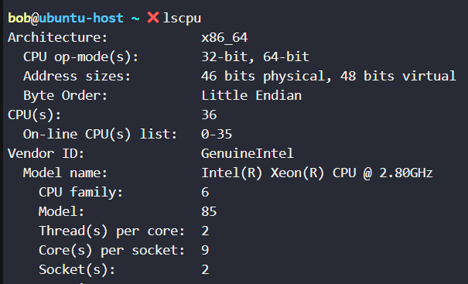

Core(s) per socket → Number of physical cores per CPU socket.
Socket(s) → Number of physical CPUs (if multiple CPUs exist).
Thread(s) per core → If this is 1, then CPU(s) = physical cores (no HT). If this is 2, then Hyper-Threading is enabled.

HT - Hyper-Threading

A single physical core can handle two logical processors due to Hyper-Threading.
If a CPU has 8 cores with Hyper-Threading enabled, it will have 16 logical processing units.

Modify the security limits file and make sure that the user called trinity can run no more than 30 processes in her session.
This should be both a hard limit and a soft limit, written in a single line.

nproc - max number of processes

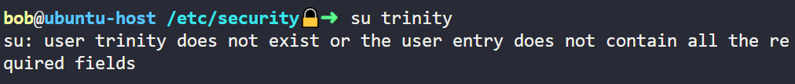

Edit the /etc/security/limits.conf file:
sudo vi /etc/security/limits.conf
Add the below line at the end of the file:
trinity - nproc 30
Save and exit.

verify using:
sudo -iu <username> logs you in as <username>, without having to know <username>'s password.

Identify all the security limits currently applied in our user's session

ulimit -a > /home/bob/limits

ulimit

-a all current limits are reported

is used to see, set, or limit the resource usage of the current user. It is also used to set restrictions on the resources used by a process.

✅ulimit -a shows the active limits for your session, whether set explicitly or inherited.
✅ /etc/security/limits.conf only contains manually configured limits—if it’s empty, defaults still apply!

Modify the sudoers file in such a way to allow the user called trinity to run any sudo command without needing to provide her password.

Edit the /etc/sudoers file:

sudo visudo /etc/sudoers
Add the below line at the end of the file:

trinity ALL=(ALL) NOPASSWD: ALL
Save and exit.

Edit the /etc/sudoers file:

sudo visudo /etc/sudoers
Remove the previous entry for trinity user and add the below line at the end of the /etc/sudoers file:

trinity ALL=(ALL) /usr/bin/mount

  - data: Prevents a process from consuming excessive memory, avoiding system slowdowns. e.g. trinity hard data 1048576
  - fsize: Ensures users don’t create massive files that may fill up disk space. e.g. trinity hard fsize 524288

Define a policy for all users for saleteam group to run all sudo command

sudo visudo /etc/sudoers
%salesteam ALL=(ALL) ALL

Define a policy so that user trinity can run sudo commands as the user sam.

Edit the /etc/sudoers file:

sudo visudo /etc/sudoers
Add the below line at the end of the file:

trinity ALL=(sam) ALL
Save and exit.

Now add a new entry that allows trinity to run all commands with sudo, but only after entering the password.

sudo visudo /etc/sudoers
trinity ALL=(ALL) ALL

User and Groups: Manage Root account access
Saturday, December 14, 2024
9:04 PM

To login as root, run command

sudo --login OR sudo -I

To exit, run
logout

If a user don’t have sudo privileges but it has root password, run

su - OR

su -l OR
su --login
Some systems have root users locked. It means we can't regular login with root user and its password. So, we can use:

sudo --login OR sudo -l

But we can't use su - bcoz it will ask for root user password and that is locked.

If a root user is locked and we want to allow a user to login as root, there are following options

- If a root user neved had a password, we can choose a new password for it: sudo passwd root
- If a root user has a password, we can unlock it using - sudo passwd --unlock root

After this we can run, su - to login .

To lock password based login to root account, run:
sudo passwd --lock root OR
sudo passwd -l root

User and Groups: LDAP User and Groups
Saturday, December 14, 2024
11:27 PM

/etc/passwd = It seems misleading from the name but it contains the information of the user accounts such as username, userid, home directory, and shell.

LDAP

Lightweight Direcrtory Access Protocol

There can be 100+ servers and it's hard to manage useraccount of each server. So, LDAP server is a central directory which keeps the records of useraccouts which can be managed from one place only. We can configure our servers to use this LDAP servers.

lxc

lxd

Steps to Initialize lxc
Run command: lxd init

command to lict lxc containers
lxc list

command to start lxc containers
lxc start <container-name>

How to use LDAP Servers

- One way is to install package:
sudo apt update && sudo apt install Iibnss-ldapd

'nss' in libness stands for name, server and switch

- Configuring nslcd = name server local daemon. This is responsible for retrieving data from our LDAP servers.
  - type the IP address of the LDAP server.
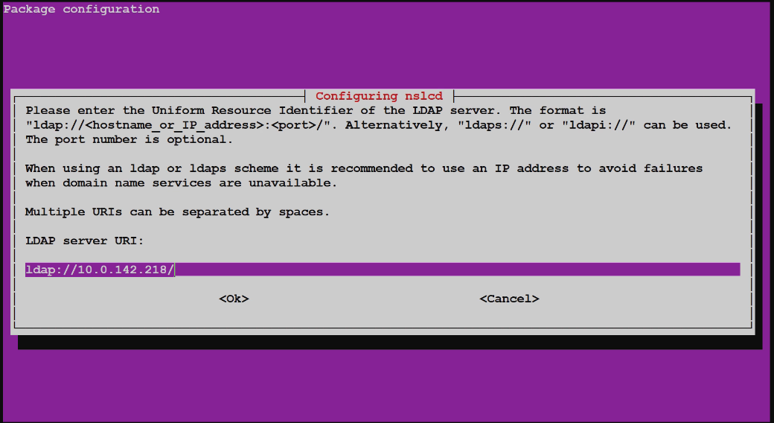

- After this, we need to enter the name of the LDAP search base. This is used to tell the nameserver local daemon, which segment of this tree is storing the information.

Organization is tree, departments are segments.

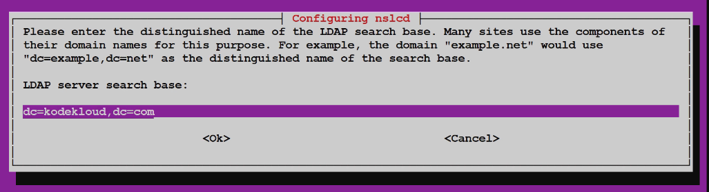

dc = Domain Component

- Now we inform what are the files we need to store at the LDAP Server. In below example we are storing passwd( users), group( group), shadow( passwords) to the LDAP Server.

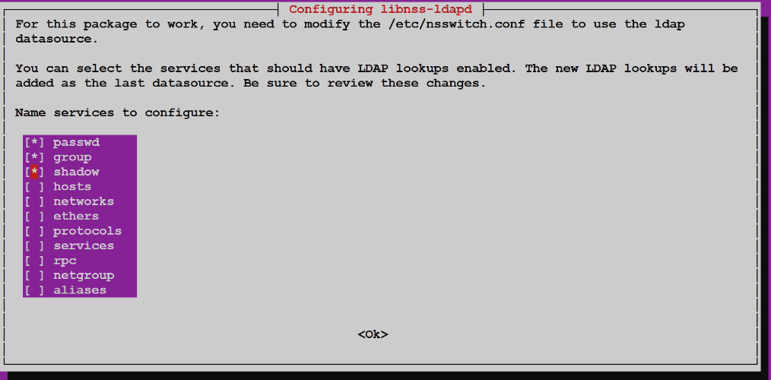

This modifes a file called /etc/nsswitch.conf stand for name server switch. Now /etc/nsswitch.conf looks like

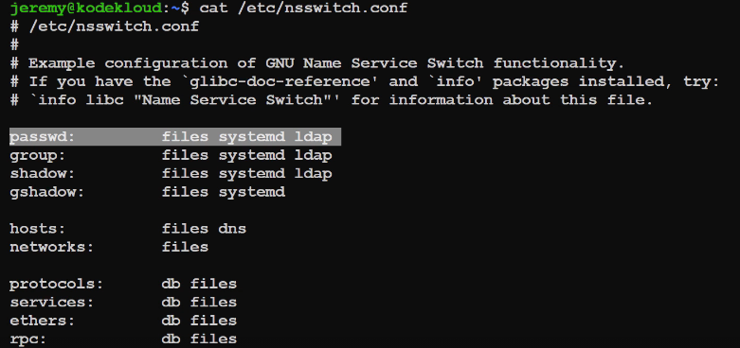

nslcd

name server local daemon
It's file is /etc/nslcd.conf

This file will have the information that we entered in step 2a and 2b

To find a user locally and also on the LDAP server, run the following command

getent passwd

getent stands for Get Entries, this commands asks nsswitch.conf for the data.

To find a user only on LDAP server, run command

getent passwd -- service ldap

To find a group only on LDAP server, run command

getent group-- service ldap

When a server is configured with LDAP, all the user doesn't have their home directory when they login.
So, there's a module called pam, which automatically creates a home direcotry for a user who logs in .

If you don’t find your home direcotry when you logged in, run:

sudo pam-auth-update

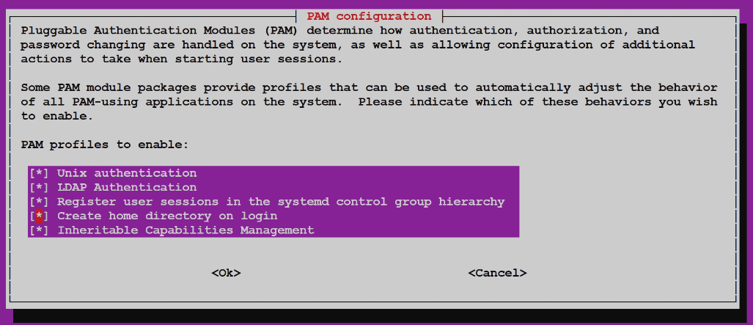

Click on "create home directory on login"

Files
Monday, January 27, 2025
1:12 AM

/etc/group

group_name:password:GID:user_list

Example:

sudo:x:27:

sudo: The name of the group.
x: Indicates no group password is set or that shadow passwords are in use.
27: The GID assigned to this group.
: Users who are members of the sudo group.

The absence of user names after the colon in the /etc/group entry for sudo simply means that the group's membership is not defined within that specific file.

/etc/sudoers

This file specifies which users or groups are allowed to use the sudo command and under what conditions.

useradd vs adduser
Tuesday, January 28, 2025
12:44 AM

